



<https://github.com/TheJollyLaMa/BabelBet>

Justin LaManna, aka The Jolly LaMa

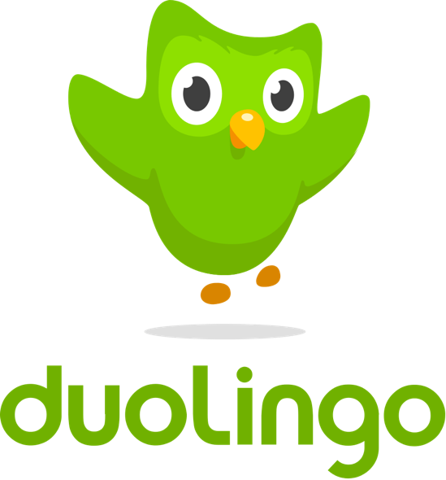

Babel Bet

UML Use Case Diagram

**Babel Bet**

**Use Case:**

A Duolingo student enters the BabelBet URL into a web browser equipped with metamask and fills the form to initiate a challenge with another Duo student. An email is sent and the other student can either counter offer or accept the terms and enter into a “Dual ‘o Lingo”. On acceptance, funds are staked from each player’s wallet to the BabelBet contract and an ERC-1155 is minted on the Polygon/Matic blockchain network.

While students have their funds locked in the contract and they try to meet the terms of the challenge, the locked funds are used to generate yield, i.e., swept over into aave to deposit in a yield bearing token. Students are more likely to meet their language learning goals while funds are staked because …

If they fail to meet the goal, funds are forfeited to the contract.

Whoever meets the terms of the challenge splits the forfeited funds plus interest.

 If no one meets the challenge, all funds are forfeited to the BabelBet contract.

You keep your ERC-1155 as memorabilia! Come back and view it anytime ☺